Name: Tung Do Lab #3 Date: September 29, 2022

Objectives: The objective of this lab was to read the data from the given file, then find the mean and standard deviations and write to an output file. Thus, in order to perform the lab, I need to know how to scan the code then store each number from each line into an array, then perform calculation using that array then printout the result.

**Program:**

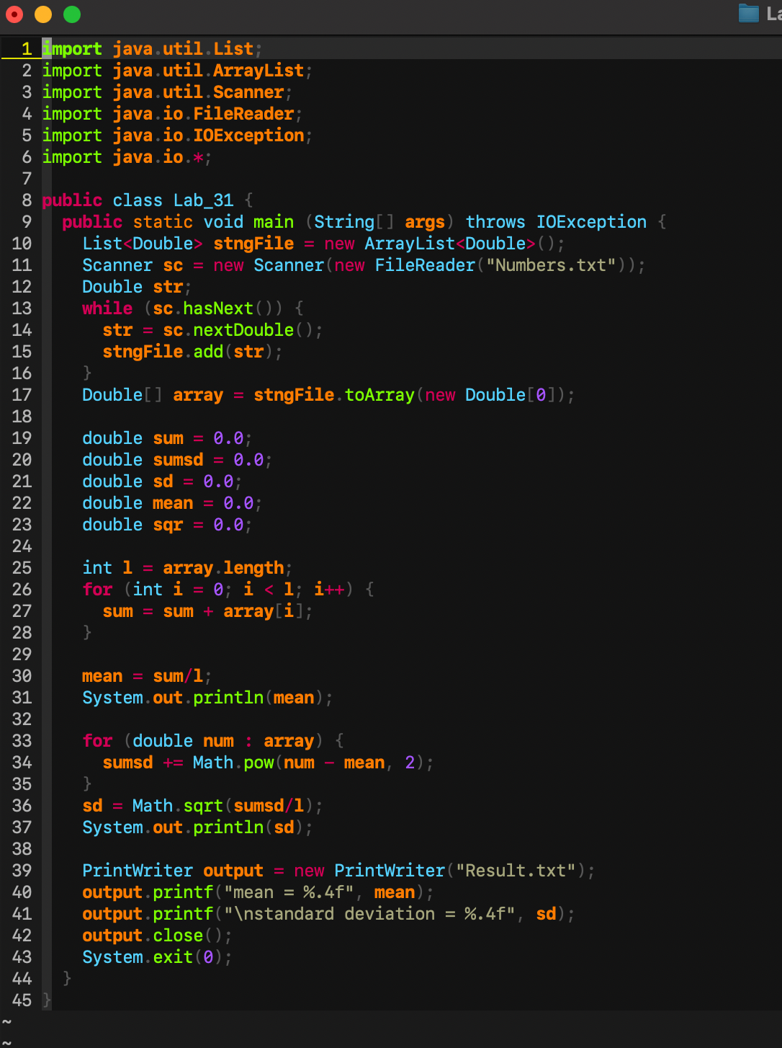

**Results:**

* The console log that prints out the mean and standard deviations

* The output file that prints out the mean and standard deviations

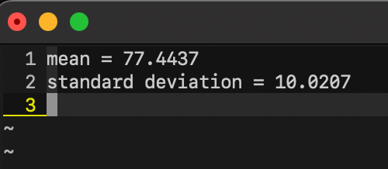

**Conclusion:**

During the coding process, I have some problems with the standard deviations calculation. Then I change the code for calculating and it worked fine. As a result, my program is able to read the data from a file, store them into an array, and perform calculation for mean and standard deviations and print the result in an output file. So the objective of the lab 3 has been done.